Project submission requirements

Before you submit any project make sure all require information is shown.
The first task you do is to check the instrument (2 Peg Test). The test can be done close to survey store. There are mounted staff portion on walls at survey store and at toilet south end at music (G) block.
Please note:
There is a dress policy. Student cannot get any equipment if not correctly dressed. Safety Officers carry out regularly checks for compliance.
For the projects use your own field notes and leave the project sheets for your final submission. Rise & fall sheet can be obtained from your lecturer. Don’t forget the arithmetic check.
Transfer field notes onto your Rise & Fall Project sheets. Make sure all figures and text is unambiguous and clearly legible. Letter and number must not be smaller than 3 mm in height).
For practical projects you do need to draw a section showing a ground profile. Figure 1 shows the necessary information that must be shown.
Baseline and horizontal & vertical scale as listed on your project sheets need to be shown. Make sure your scale is the same as listed in the instructions.

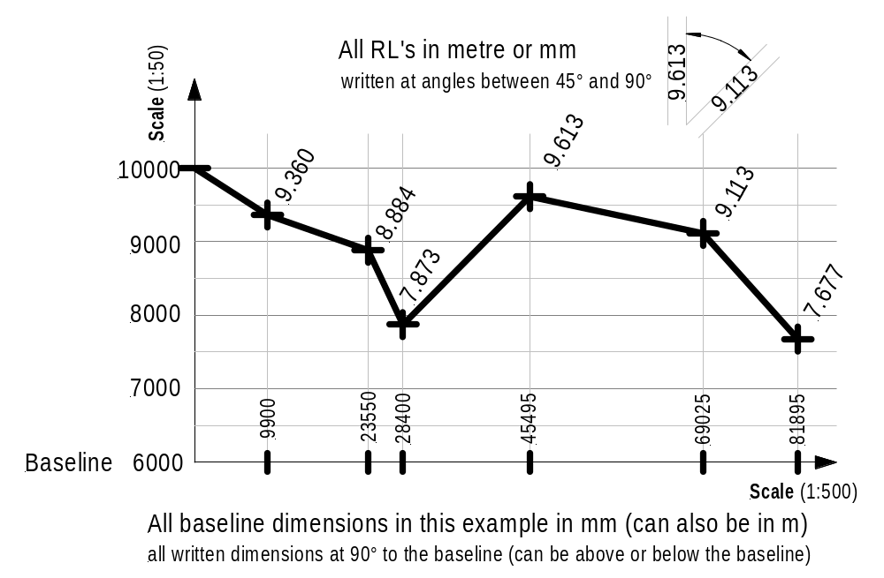Profile Example

All distance measurement accumulative in your Profile drawing

Figure 1

All writing whether text or numbers must be clear & legible (text & figure height ≥3 mm). Each RL must be clearly marked above the dimension on the base line. All lines must be parallel & drawn with a ruler (construction gridlines should be faint and the profile line a thick line).
If the profile drawing (legibility of text & numbers, accuracy of the scales (horizontal & vertical) and other requirements are not satisfactory you submission will not be assessed and you need to resubmit your work.
Karl Boeing

